Fully Automated Irrigation System

A.Arvind Desai

B.Tech.student

Rajarambapu Institude Of Technology Isalampur,Maharastra,pin:415409,India

Mail:adityadesai2001@gmail.com

A.Ashok Nagargoje

B.Tech.student

Rajarambapu Institude Of Technology Isalampur,Maharastra,pin:415409,India

Mail:aishwaryanagargoje@gmail.com

S.Ranjit Patil

B.Tech.student

Rajarambapu Institude Of Technology Isalampur,Maharastra,pin:415409,India

Mail:shreyaspatil9146@gmail.com

D.Sachin Desai

B.Tech.student

Rajarambapu Institude Of Technology Isalampur,Maharastra,pin:415409,India

Mail:shreyaspatil9146@gmail.com

**Abstract :**

Our project is a fully automated irrigation system that highlights the optimum solution for the efficient use of water and electricity for agricultural purposes. There are some existing systems who come up with two solutions, one is timer-based and another one is moisture-based atomization. The timer-based system has demerits like being semiautomated i.e. timer needs to be changed manually according to climate. Similarly, in moisture-based systems, reliability is the issue. So the main objectives of the paper are to overcome the demerits of the present systems by integrating both the systems, to develop a fully automated irrigation system, to manage the use of water, electricity, and to add a remote controlling system. The paper includes the integration of moisture and timer-based system which provides the optimum efficiency on the water use and the use of solenoidal valve and siphon technology decreases the use of electricity while our third idea to prepare a smartphone application gives us the advantage to continuous monitoring over the system and provides control over irrigation from anywhere.

# **Introduction:**

India's ground water levels are critically low and present irrigation systems are poor in efficient water and energy management. So there is definite need of developing the efficient system for irrigation of water. Our project is a fully automated irrigation system that highlights the optimum solution for the efficient use of water and electricity for agricultural purposes. The existing systems come up with two solutions, one is timer-based and another one is moisture-based. The time-based system has demerits like being semiautomated i.e. timer needs to be changed manually according to climate. Similarly, in moisture-based systems, reliability is the issue. So our main objectives are to overcome the demerits of the present systems, to develop a fully automated irrigation system, to manage the use of water, electricity, and to add a remote controlling system. Our idea includes the integration of moisture and timer-based system which provides the optimum efficiency of water and the use of solenoidal valve and siphon technology decreases the use of electricity while our third idea to prepare a smartphone application that gives us the advantage to continuous monitoring over the system and provides control over irrigation from anywhere.

1)Mehamed Ahmed Abdurrahman (2015) Sensor Based Automatic Irrigation Management System: International Journal of Computer and Information Technology (ICIT) In the present review, an attempt has made to make an automatic irrigation system using PIC 16F877A, moisture sensor and induction valve. The sensors are used to measure the moisture level of an soil and control the valve according to the level of moisture

2) Bishnu Deo Kumar, Prachi Shrivasthay, Reetika Agrawal and Vanya Tiwari (2017) Microcontroller based automatic plant irrigation system: International Research Journal of Engineering and Technology (IRJET):In the present review, an attempt has been made to provide Information about the automated irrigation system using microcontroller (ATMEGA 328). The efforts are made to provide continuous readings of the temperature of atmosphere along with humidity content of soil with an Automated control over irrigation based on ATMEGA 328 and GSM module.

3)Raja. G. Abhiraj. R. Arunkrishnan, Febin Malik. Jesu Jorof Divin. J and Rajarathinum (2018) Smart Polyhouse Farming Using lot Enviroment: International Journal Of Trend in Scientific Research and Development IJTSRV)In this paper some essential sensors, Relay and Power supplies used in (polyhouse are discussed in brief. The sensors which have been discussed are Temperature, Humidity, Moisture and ultrasonic sensors. By implementing automation inside the polyhouse all things are monitoresd through mobile.

4)R.Nageswara Rao,B.Sridhar(2018)IOT Based Crop Filed Monitoring And Automation Irrigation System: **s**econd international coferance on inventive system and control(ICISC)This system is used for controlling and monitoring of crop field and this research paper describe the block diagram of IOT based automatic crop field monitoring.

5)G.K.Banerjee,Rahul Singhal(2010)Microcontroller based polyhouse automation controller :International symposium on electronic system design.

In this research paper they discussed that how to control the temperature and relative humidity inside polyhouse using microcontroller.

**BLOCK DIAGRAM:**

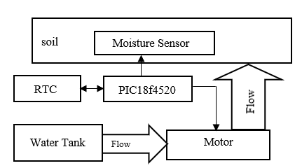

The RTC module provide real time and date to the microcontroller.

So the microcontroller could regulate the water according to the

Shedule and the function of moisture sensor is the to sense the

moisture content in the soil.if the moisture content goes low

it could overload the schedule and gives water content to the soil

**FLOWCHART:**

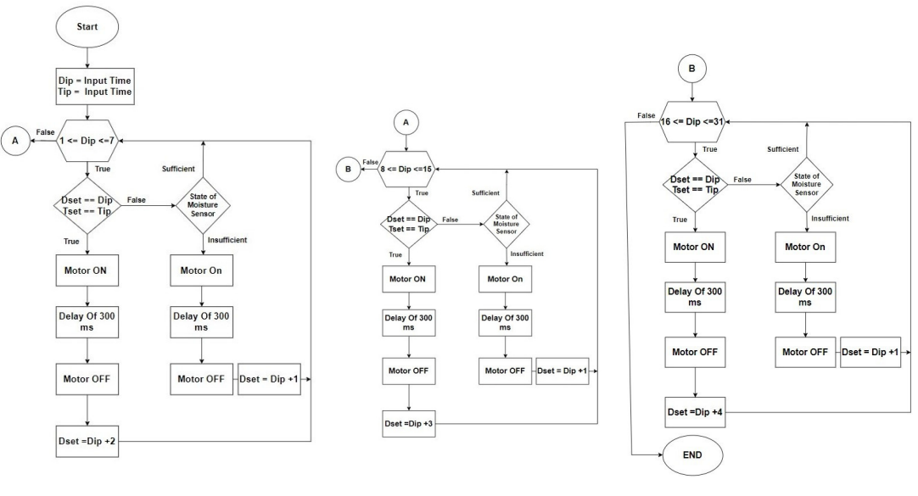

**For 1st week:**

The microcontroller does write operation on the RTC module then the continuous time and date are transferred to the microcontroller and value of date and time are copied into Dip=Tip variables **.**Now if Dip (input date is less than 7)then the loop for week 1 got executed. now if input date and input time are matched with the set date and set time then the motor turned ON.After that proper delay it applicable to keep motor turned on for few minute after that signal is provided so that motor turns OFF. Then Dset (set date)is increased by 2 days(Dset=Dset t)And it again jump to weak condition check unless date is not move than 7 it stay in some loop. Now if the set date and set time are not equal to input date and input time then sufficient then again jumped to week check in condition if it is motor turn off. again Dset is changed to (Dset T1) and jumped weak check condition if date is grater than 7 and less than 15 it enter into second loop.

**For 2nd week:**

Now if Dip (input date is less than 15)then the loop for week 2 got executed. now if input date and input time are matched with the set date and set time then the motor turned ON.Then proper delay it applicable to keep motor turned on for few minute after that signal is provided so that motor turns OFF. Then Dset (set date)is increased by 3 days(Dset=Dset )And it again jump to weak condition check unless date is not move than 15 it stay in some loop. Now if the set date and set time are not equal to input date and input time then moisture comes into play.it checks the moisture level of soil. if sufficient then again jumped to week check in condition if it is insufficient. then it bypasses timer and turn on the motor.after delay motor turn off. again Dset is changed to (Dset T1) and jumped weak check condition if date is grater than 15 and less than 30 it enter into third loop.

**For 3RD week:**

Now if Dip (input date is less than 30)then the loop for week 3 got executed. now if input date and input time are matched with the set date and set time then the motor turned ON.Then proper delay it applicable to keep motor turned on for few minute after that signal is provided so that motor turns OFF. Then Dset (set date)is increased by 4 days(Dset=Dset t)And it again jump to weak condition check unless date is not move than 30 it stay in some loop. Now if the set date and set time are not equal to input date and input time then moisture comes into play.it checks the moisture level of soil. if sufficient then again jumped to week check in condition if it is insufficient. then it bypasses timer and turn on the motor.after delay motor turn off. again Dset is changed to (Dset T1) and jumped weak check condition if date is grater than 30 .it enter into first loop.

**HARDWARE IMPLEMENTATION:**

**RTC:**

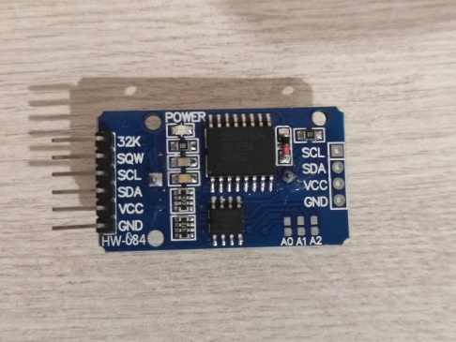

RTC stands for real time clock .It is used for keeping

information regarding second, mintues,

Hours day, week, year

**I2C**:

##### 

I2C stand for inter integrated circuit which is

Used to provide communication between RTCds3231

And pic18f4520.

**PIC18F4520:**

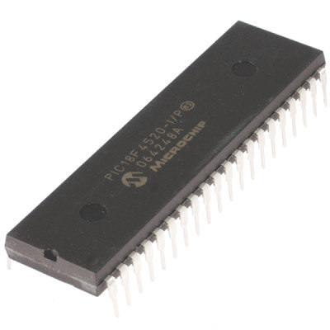

PIC18F4520 used to generates two different clock

Signals.it is mainly used in automation and

Embedded systems.

###### 

###### **resistive soil moisture sensor:**

###### 

The moisture sensor is used for measure the control of Water.If the water is more then the soil will conduct more electricity that means there will be less resistance. Therefore, the moisture level will be higher. Dry soil conducts electricity poorly, If there will be less water, then the soil will conduct less electricity which means that there will be more resistance. Therefore, the moisture level will be lower.

##### **RESULTS AND DISCUSSION**:

|  |  |  |  |  |
| --- | --- | --- | --- | --- |
| SR.NO | COMPONENTS NAME | CURRENT RATING | VOLTAGE RATING | POWER RATING |
| 1. | **RTCDS3231** | **100-170 micro amp** | **2.2-5.5 v** |  |
| 2. | **CAPACITIVE SOIL MOISTURE** | **5 ma** | **3.3v** |  |
| 3. | **LCD DISPLAY** | **1 ma** | **4.7 v -5.3 v** |  |
| 4. | **RELAY** | **5AMP** | **12V** |  |
| 5. | **WATER PUMP** | **5amp** | **12v** |  |
| 6. | **PIC18F4520** | **5.8micro** amp | **2.2 -5.5v** |  |
|  |  |  |  |  |

##### For a Conventional System (half Hp motor) 1960/2 = 980*30 = 29400 1960 litre per hour ; for a per day 30 mins of use = 1960/2 = 980 litre for a month 980*30 = 29400 litre our system 12V 110psi motor = avg 200 ltr per hour for a per day 30 mins of use = 100 litre per day for 6 motor 100*6=600 litr per day 600*30 = 18000 liter

##### **References**

[1] Mehamed Ahmed Abdurrahman (2015) Sensor Based Automatic Irrigation Management System : International Journal of Computer and Information Technology (IJCIT) , Vol. 04, Issue. 03, pp. 05-15

[2] Bishnu Deo Kumar, Prachi Shrivasthav, Reetika Agrawal and Vanya Tiwari (2017), Microcontroller based automatic plant irrigation system : International Research Journal of Engineering and Technology (IRJET), Vol. 04, Issue. 05, pp. 05-17

[3] Raja. G, Abhiraj. R, Arunkrishnan, Febin Malik, Jesu Jorof Divin. J and Rajarathinum (2018), Smart Polyhouse Farming Using Iot Enviroment: International Journal Of Trend in Scientific Reasearch and Development (IJTSRV) , Vol. 02, Issue. 03, pp. 03-18

[4] R.Nageswara Rao,B.Sridhar(2018)IOT Based Crop Filed Monitoring And Automation Irrigation System: **s**econd international coferance on inventive system and control(ICISC)

[5] G.K.Banerjee,Rahul Singhal(2010)Microcontroller based polyhouse automation controller:International symposium on electronic system design